Using tomosynthesis for detection of pneumonia caused by COVID-19

Sergii Miroshnychenko
Teleoptic PRC, ltd
Kyiv, Ukraine
s.miroshnichenko@teleoptic-pra.com.ua
Yurii Khobta
Teleoptic PRC, ltd
Kyiv, Ukraine
Yuriy.Khobta@teleoptic-pra.com.ua
Andrii Nevgasimyi
Teleoptic PRC, ltd
Kyiv, Ukraine
a.nevgasymyi@teleoptic-prc.com

Sergii Senchurov
Teleoptic PRC, ltd
Kyiv, Ukraine
s.senchurov@teleoptic-prc.com
Oleksandra Miroshnychenko
National Aviation University
Kyiv, Ukraine
o.miroshnychenko@nau.edu.ua

Dmytro Radko
Teleoptic PRC, ltd
Kyiv, Ukraine
dmitriy.radko@teleoptic-pra.com.ua
Ilyinska Olena
Radiologist

Abstract—This article consider the possibility of using digital X-ray tomosynthesis for the diagnosis of lung pathologies, including the detection of the early stages of COVID-19. The advantages of this method in comparison with digital radiography and computed tomography are shown. Digital tomosynthesis is considered as an additional option, which is recommended to be installed on all existing basic radiographic systems with their transfer to digital technologies.
Keywords—digital tomosynthesis, computed tomography, digital radiography, COVID-19.

Introduction
The beginning of 2020 was marked by the COVID-19 pandemic. At the time of this writing, more than 1 million 119 thousand cases of the disease have been confirmed worldwide, with 59 thousand patients died due to it. In a short time, measures unprecedented to date have been taken to limit the spread of this disease. All governments have, to one degree or another, increased their health care budgets. Due to the limited transport connections between countries, rich people from poor countries were locked up in their own health care systems, deprived of the opportunity to receive treatment abroad. This led to the infusion of huge, previously inaccessible private funds into equipping the health system.
Laboratory methods provide data on patients who are infected with the virus. However, a significant number of cases are asymptomatic or have a mild disease. Since there is no specific treatment for this disease and it is symptomatic, there is a need for screening for pneumonia, which is the cause of high mortality from COVID-19.
According to researchers who diagnosed and treated patients with confirmed COVID-19 who developed pneumonia, the best method for diagnosing the early stages of the disease is computed tomography (CT) (Fig. 1.a) [1-3]. At later stages, the use of conventional digital chest radiography (DR) is sufficient (Fig. 1.b).
The use of these methods (especially together) makes it possible to identify cases of the disease. However, each method in itself has a number of disadvantages.
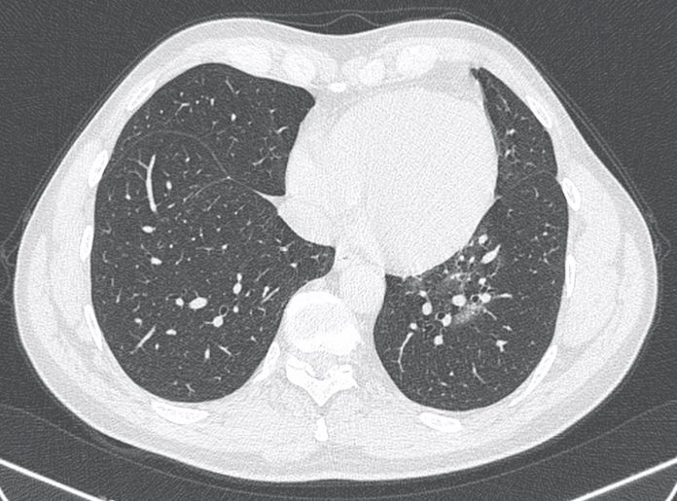
а)
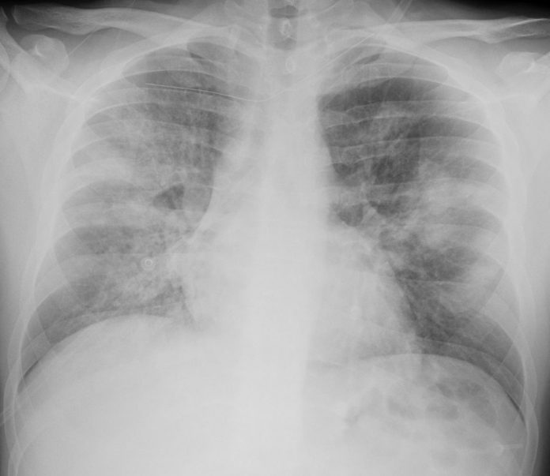
b)
Fig. 1. Examples of the application of X-ray diagnostic methods for the detection of pneumonia caused by COVID-19: a) - CT, b) - DR [1].
The easiest and economic method for chest diseases diagnosing is digital radiography. This method allows to obtain images with high resolution (up to 5 lp/mm) in field studies. However, due to the fact that the image is an X-ray shadow of all tissues, some structures are superimposed on others. This leads to the fact that the sensitivity of this method for low-contrast chest pathologies is not more than 40%. The main advantage of this method is the relatively low radiation dose to patients, which does not exceed 0.1 mSv and the low cost of these systems. Basic X-ray systems recommended by WHO for the equipment of X-ray rooms in reception departments of medical institutions. Time of disinfection or change of the outer covers of the parts of the X-ray systems to which patients can touch between examinations is 3-5 minutes.
The current gold standard for diagnosis is computed tomography (CT). It allows you to get images of slices of the studied object, thereby eliminating the effect of overlapping images of different structures on each other. The sensitivity of CT for the diagnosis of pneumonia caused by COVID-19 reaches 98% and its use gave a result 4..8 days earlier than laboratory tests [4]. This method has the relatively low resolution (1 lp/mm) and a high radiation dose on the patient - up to 3-7 mSv, which significantly exceeds the WHO threshold of 1 mSv per year. Given the massive need for surveys during a pandemic, this will significantly increase the overall dose burden of the population. Another non-diagnostic, but purely economic disadvantage of this method is its high cost. Not all clinics can afford to install and maintain this equipment. Time of disinfection of the parts of the CT to which patients can touch between examinations can reach up to 1 hour.
Thus, both classical methods have their advantages and disadvantages for the diagnosis of pneumonia caused by COVID-19.

Materials and Methods
Digital X-ray Tomosynthesis (DT) combines the advantages of both CT and DR. The scheme of this method is presented on Fig. 2.
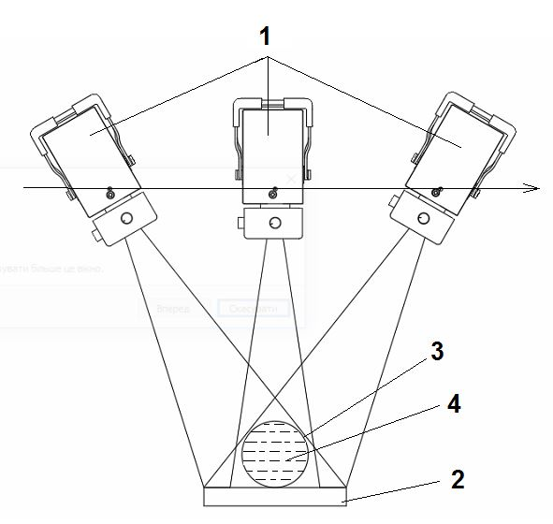
Fig. 2. Scanning principle: X-ray tube -1, DDR -2, object under study - 3, position of the tomosynthesis layers of the object – 4
DT is rarely used in medicine than CT and DR but this method has several advantages. The resolution of this method reach up to 2 lp/mm. According to studies [5 and other], the sensitivity of this method for the diagnosis of lung pathologies reaches up 90% which exceeds the sensitivity of digital radiography and close to computed tomography. Radiation dose of this method in 3-5 times more than by DR but in 10 times less than by CT – up to 0,5 mSv that respond to requirements of WHO screening.
The scanning procedure itself lasts from 2.5 to 5 seconds, during which the X-ray receiver obtained from 50 to 120 x-ray images of the studied part (chest) obtained from different in row angles. Image data is transferred to the computer and processed by appropriate algorithm. As a result of this, 150-300 X-ray slices of the studied part are obtained, which parallel to the plane of the digital receiver. The depth of each slice is from 0.65 mm to 3.00 mm. Thus, the series of images are obtained, allowing to find objects in height and in width and in depth.
Figure 3. presents an external basic radiographic system with a stand for performing studies with tomosynthesis.
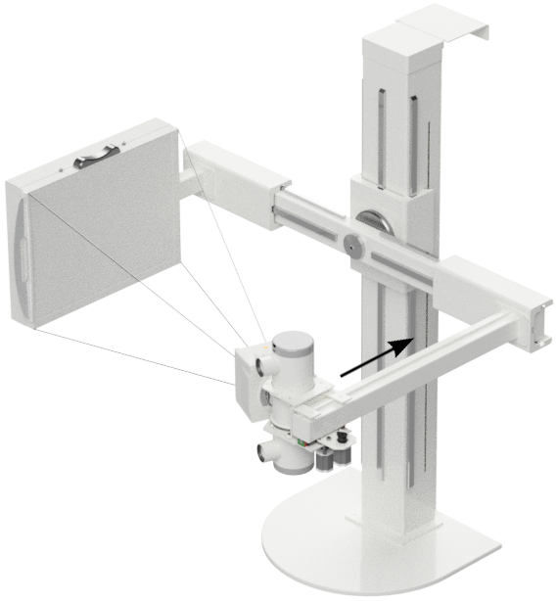
Fig. 3. External basic radiographic system with a stand for performing studies with tomosynthesis manufactured by Teleoptik SPA.

Research objective
The aim of this study is to search for the possibilities of using digital x-ray tomosynthesis for diagnosis of pneumonia caused by COVID-19.

Measurements and discussions
Studies provided by different research groups [5-6 and others] show a high level of detection of lung pathologies in the early stages of various diseases.
In Fig. 3. shows lung images of the same patient with a confirmed diagnosis of COVID-19, taken by DR and DT, Kyiv, 2020/04/03.
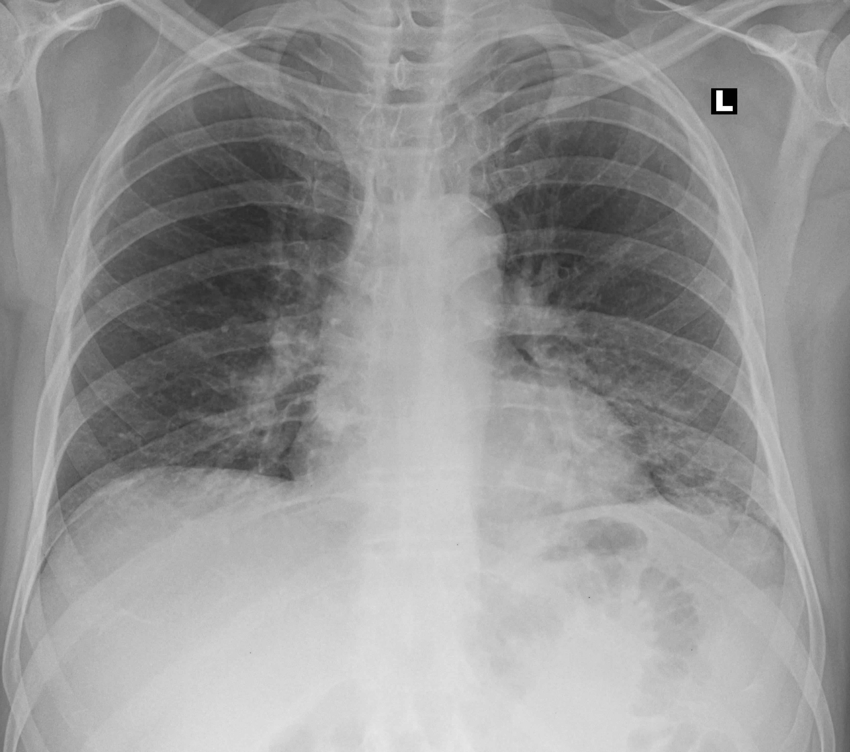
a)
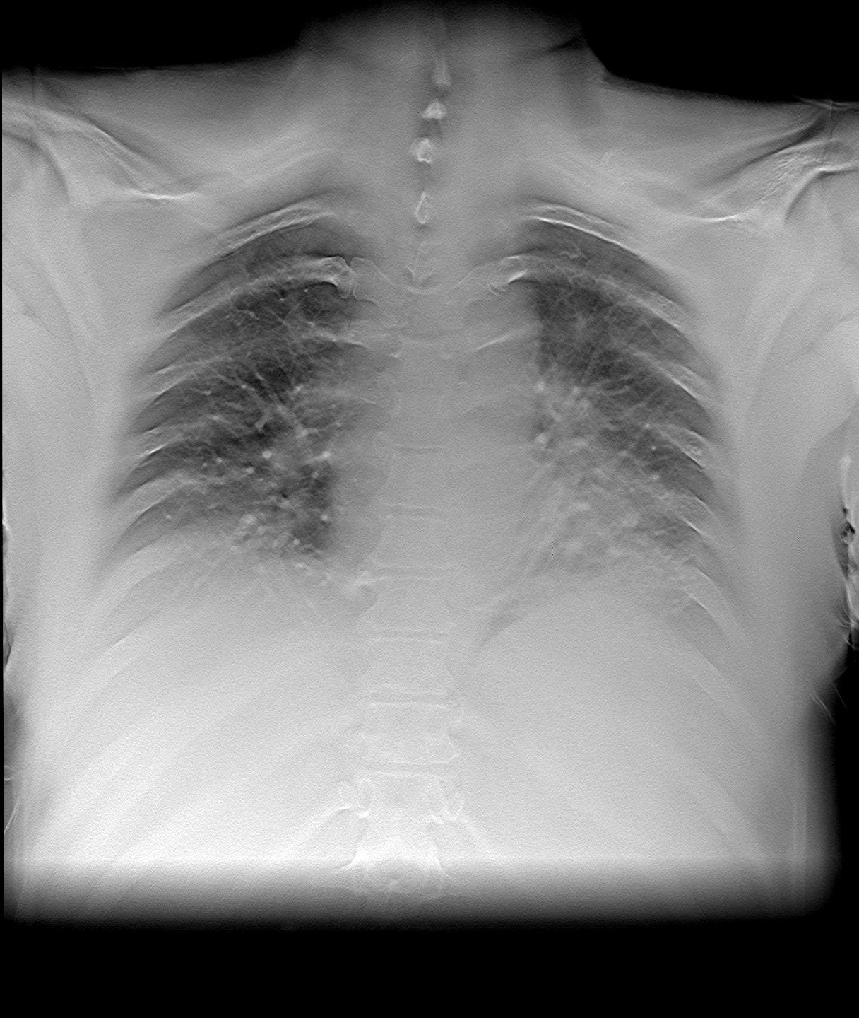
b)
Fig.4. X-ray examination of a patient with a confirmed diagnosis of COVID-19 (2020/04/03, Kyiv): a) - DR, b) - DT.
Comparative measurements of image contrast showed that on DR images the contrast of pathologies reaches pathologies not exceeding 20%, while for DT it reaches up 40%. At the same time, on DT image shoes the same ground-glass opacities which are hallmark especially early disease are clearly visible as on computed tomography images.
Conclusions
This study showed the possibility of using x-ray digital tomosynthesis for the diagnosis of the early stages of lung pathology, including COVID-19.
This method has next advantages.:
- Tomosynthesis makes it possible to obtain cross-sectional images of the patient's internal structures, which avoids the superposition of x-ray shadows of various organs and structures;
- The option of tomosynthesis can be installed on existing basic digital X-ray systems, which is much economic than buying a computer tomography, which allows them to be massively installed in the reception rooms of medical institutions;
- The time and procedure of tomosynthesis itself is 2.5-5 s comparable to the procedure for obtaining a conventional X-ray image and has the same time disinfection cycle;
- The resolution of the method reaches 2 lp/mm, which is higher than computed tomography (1 lp/mm)
- The patient's radiation dose is about 0,2-0,5 mSv which is 5 times lower than for computed tomography and complies with WHO recommendations on the radiation dose screening level of the population;
- On tomosynthesis images, the same ground-glass opacities, which are hallmark especially early disease, are quite clearly visible as on computed tomography images. The contrast of tomosynthesis images in 2 times more than of conventional digital X-ray images.

References
- https://radiogyan.com/articles/coronavirus-radiology/
- https://www.sirm.org/category/senza-categoria/covid-19/
- Fengxiang Song, MD* • Nannan Shi, MD* • Fei Shan, MD, PhD • Zhiyong Zhang, MD, PhD • Jie Shen, MD • Hongzhou Lu, MD, PhD • Yun Ling, MD, PhD • Yebin Jiang, MD, PhD • Yuxin Shi, MD, PhD. Emerging 2019 Novel Coronavirus (2019-nCoV) Pneumonia. Radiology 2020; 295:210–217 • https://doi.org/10.1148/radiol.2020200274
- https://www.rsna.org/news/2020/February/COVID-19-CT-Diagnosis-Study
- https://search1.shimadzu.co.jp/click?url=https%3A%2F%2Fwww.shimadzu.com%2Fmed%2Fsites%2Fshimadzu.com.med%2Ffiles%2Fliterature%2Ffluoro%2Fk25cur0000003yfx-att%2F26.pdf&query=tomosynthesis&charset=UTF-8&site=KWBG4K9Y&group=1.
- S.Miroshnychenko, O.Miroshnychenko, А.Nevgasymyi, Y.Khobta. “Reduction of x-ray doses in chest tomosynthesis”, 2018 IEEE 38th International Scientific Conference in Electronics and Nanotechnology (ELNANO), Kyiv, 2018, pp. 398-401

